|  |  |
| --- | --- |
| **Student Name:** | **Suntao** |
| **Student ID:** | **S1038988** |
| **Module Name:** | COMP1103 Software Development |
|  |  |
| **Lecturer** | **Mr. Loh** |
| **Submission Date:** | 14th, May, 2025 |
| **Assignment Report**  **Word Count (if applicable)）** | **1570** |
| **Declaration**    **I declare that this assignment is my own work, unless otherwise referenced, as**  **defined by the LSBF policy on plagiarism. I have read the LSBF Student handbook.**    **Submitted by: ............Suntao…............ Date .....**14th, May, 2025**......** | |

# COMP1103 Software Development

# Assignment Cover Page & Declaration

Table of Contents

1) Analysis

2) Design

3) Development

3.1 Classes and Objects

3.1.1 Branch Class

3.1.2 Employee class

3.1.3 Warehouse Class

3.1.4 Supplier Class

3.1.5 Product Class

3.2 Records of SoftDev

3.2.1 Branch

3.2.2 Employee

3.2.3 Warehouse

3.2.4 Supplier

3.2.5 Product

4) Test Cases

4.1 Branch test case

4.2 Employee test case

4.3 Warehouse test case

4.4 Supplier test case

4.5 Product test case

5) Program Listings (with comments and explanations)

6) Critical Evaluation

6.1 Strengths

6.2 Weaknesses

6.3 Future Enhancement

# Analysis

Me: Hello, I'm the project manager from SoftDev Pte Ltd. To better complete the project, I need more details. Could you introduce your company's current situation and the issues to solve?

Mr. John Doe: Our company focuses on electronic product retail, with global branches and many employees. But we lack an internal management system, unable to calculate global sales and costs, which hinders our development. I hope you can assist.

Me: Understood. Based on this, our system will manage branches and employees..

Me: For sales, we'll manage electronic products. You have warehouses, right? Also, do you have suppliers? We need to account for them.

Mr. John Doe: Thanks for reminding me. We have many suppliers. I'd like to grade them to find high - quality ones.

Me: Got it. As a commercial project, let's talk budget first. What's your budget?

Mr. John Doe: My initial budget is S$50,000. I hope to get a workable system within a month.

Me: That's doable. Let me outline the business logic. Employees belong to branches, warehouses are linked to branches. Products are associated with warehouses, and suppliers should be related to warehouses too. With branches as the core, all logic can connect. What do you think?

Mr. John Doe: Suppliers might serve multiple branches. It depends on inventory. If a branch's inventory is low, it gets priority supply.

Me: Okay, we'll set one branch to have multiple suppliers. Any other issues?

Mr. John Doe: None. Good luck, and I hope for a pleasant cooperation.

Me：Same here.

# Design

|  |
| --- |
| Employee |
| * String EName * String EId * String EContact * String BId |
| + getEName(): String  + setEName(name: String)  + getEId(): String  + setEId(id: String)  + getEContact(): String  + setEContact(contact: String)  + getBId():String  + setBId(val: String) |

|  |
| --- |
| Warehouse |
| * String WId * String WName * String WAddress * String BId |
| + getWId (): String  + setWId(id: String)  + getWName(): String  + setWName(name: String)  + getWAddress(): String  + setWAddress(address: String)  + getBId():String  + setBId(val: String) |

|  |
| --- |
| Branch |
| * String BName * String BAddress * String BContact * String BId |
| + getBName(): String  + setBName(name: String)  + getBAddress(): String  + setBAddress(address: String)  + getBContact(): String  + setBContact(contact: String)  + getBId():String  + setBId(val: String) |

|  |
| --- |
| Product |
| * String PId * String PName * double PPrice * String WId |
| + getPId():String  + setPId(val: String)  + getPName(): String  + setPName(name: String)  + getPPrice(): double  + setPPrice (price: double)  + getWId (): String  + setWId(id: String) |

|  |
| --- |
| Supplier |
| * String SId * String SName * String SContact * String[] BIds |
| + getSId (): String  + setSId(id: String)  + getSName(): String  + setSName(name: String)  + getSContact(): String  + setSContact (contact: String)  + getBIds():String[]  + setBIds(ids: String[]) |

# Development

## 3.1 Classes and objects

### 3.1.1 Branche Class

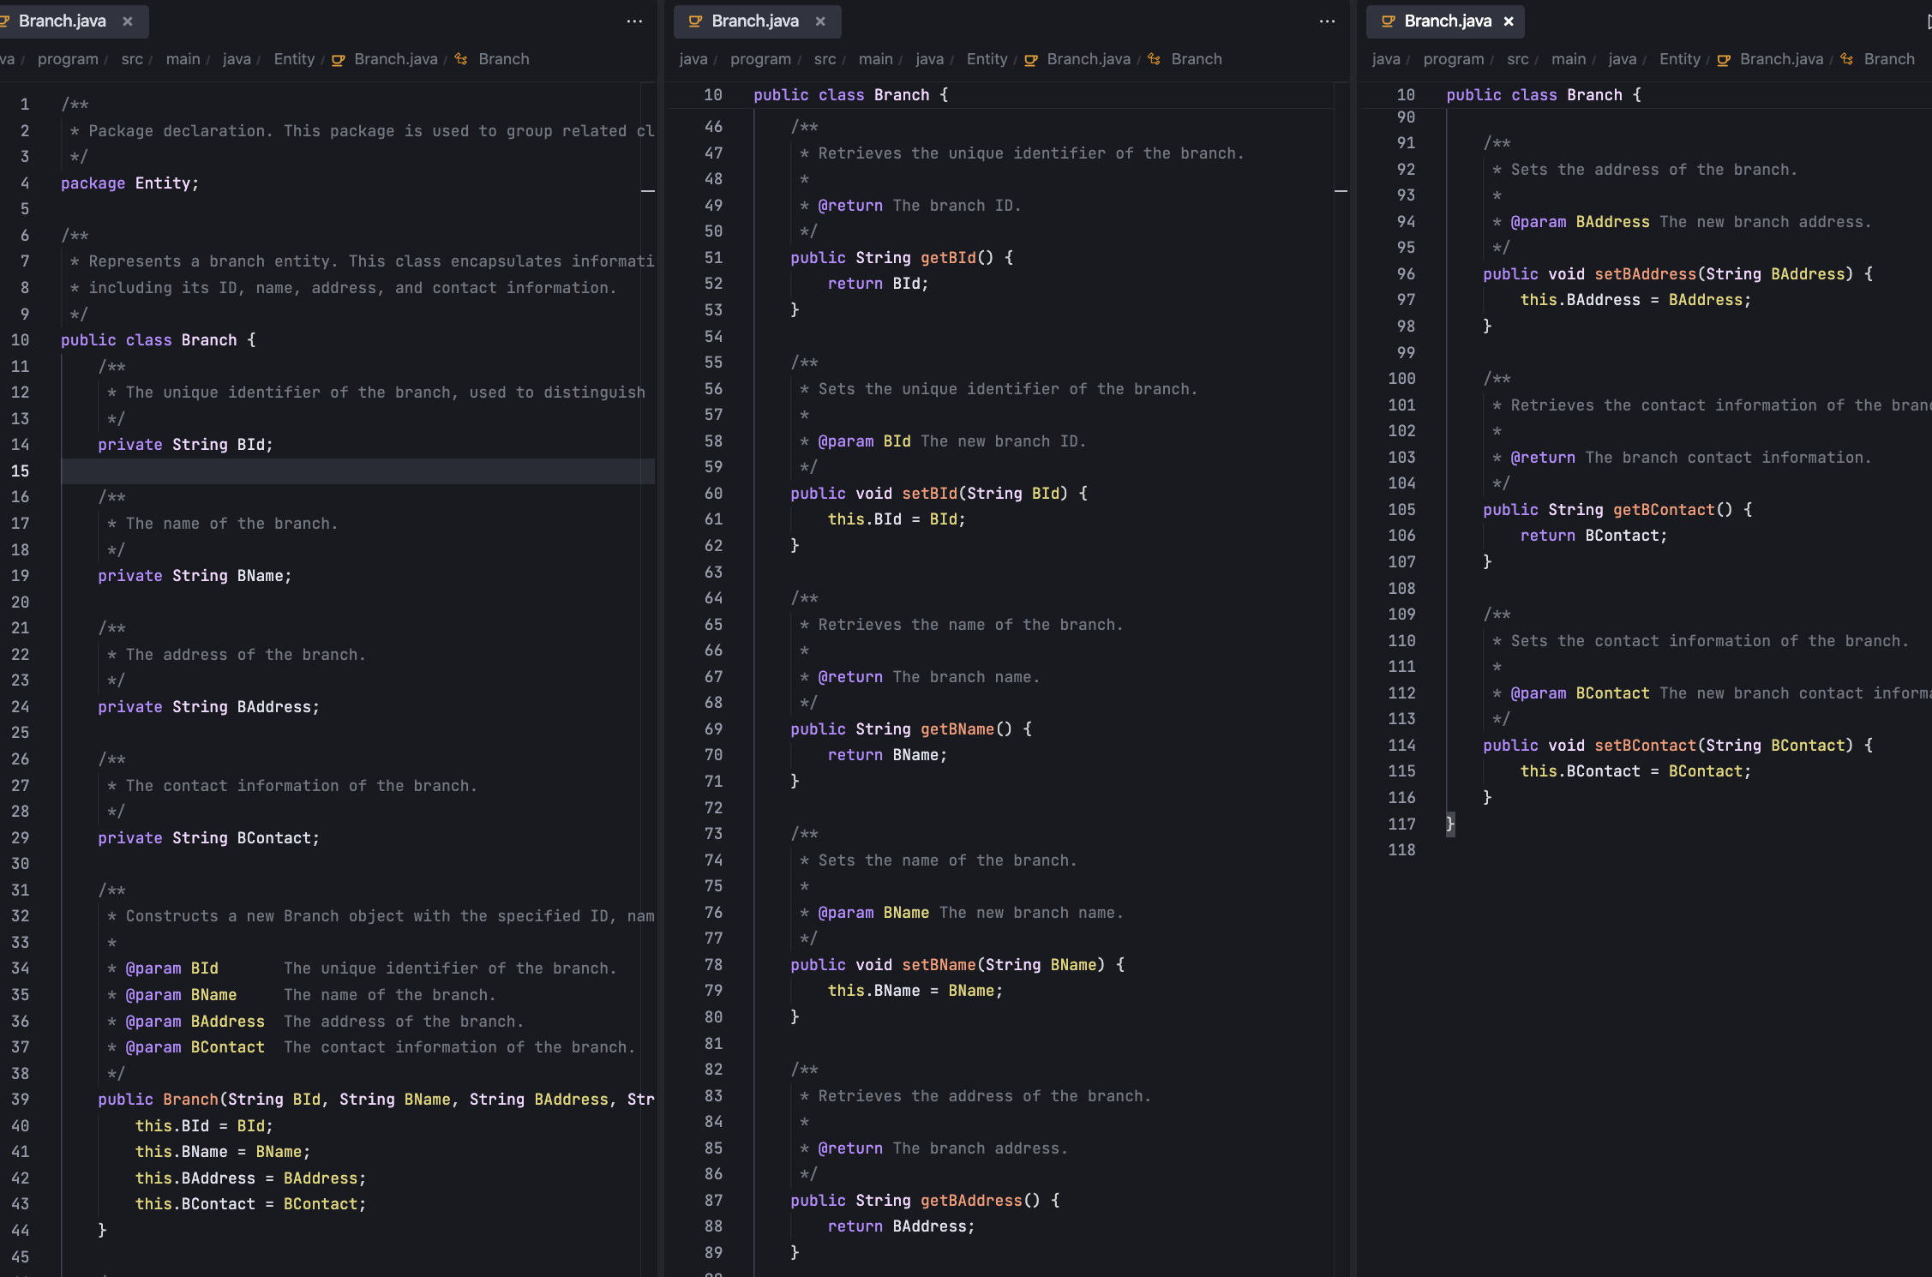

### 3.1.2 Employee Class

### 3.1.3 Warehouse Class

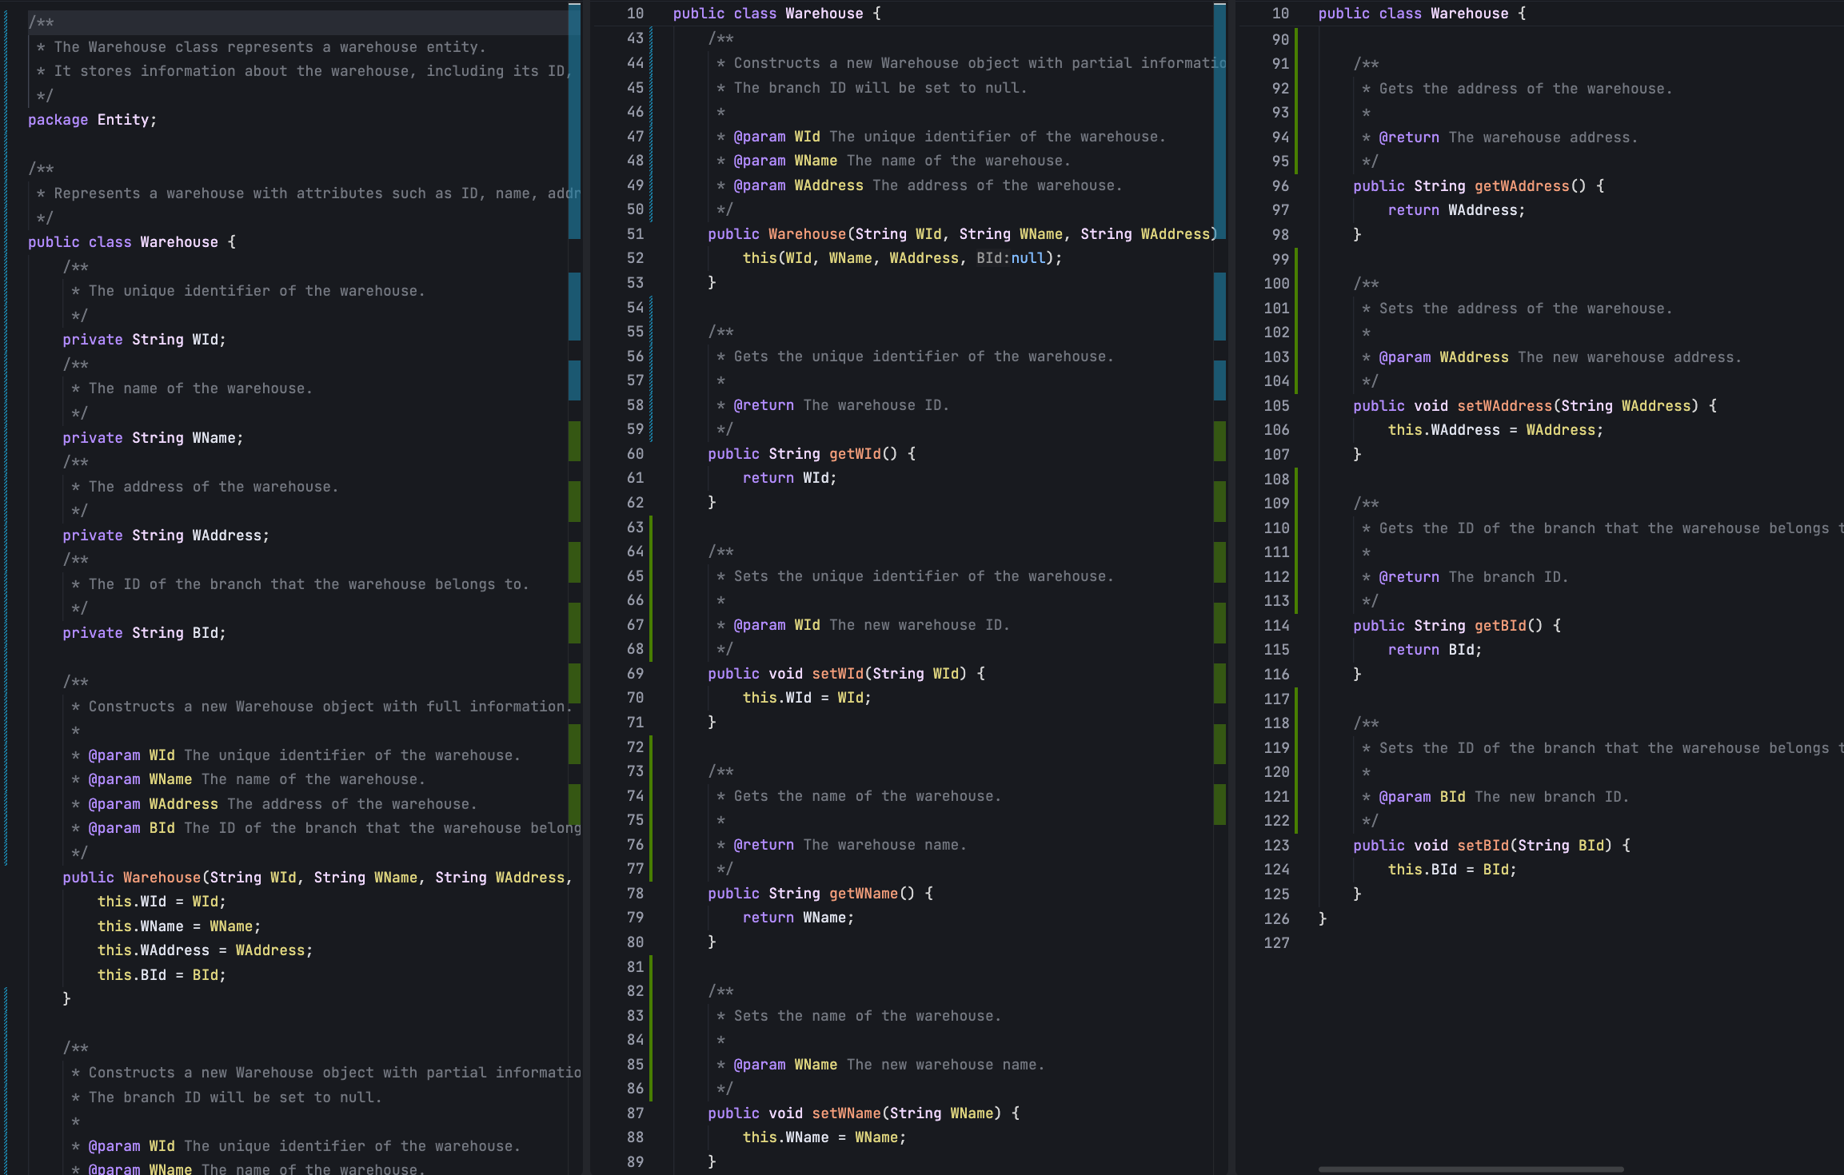

### 3.1.4 Supplier Class

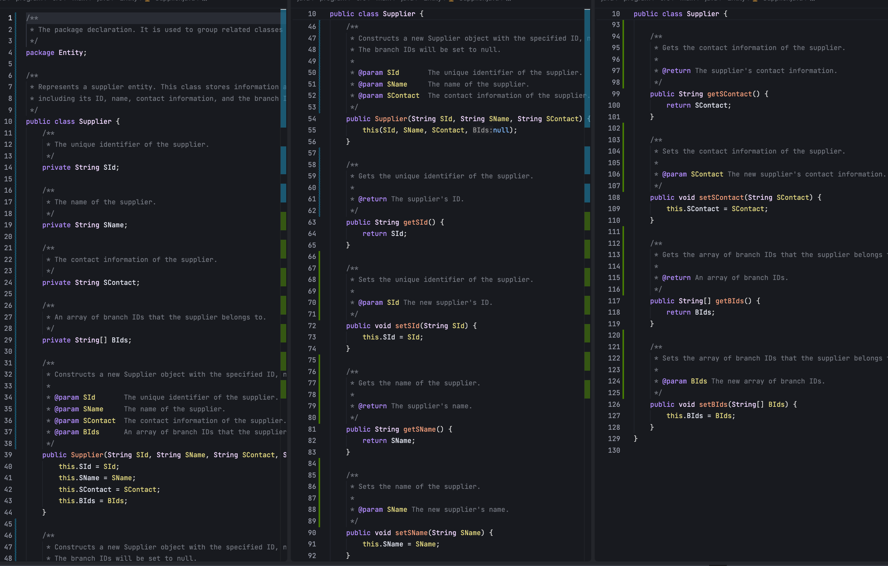

### Product Class

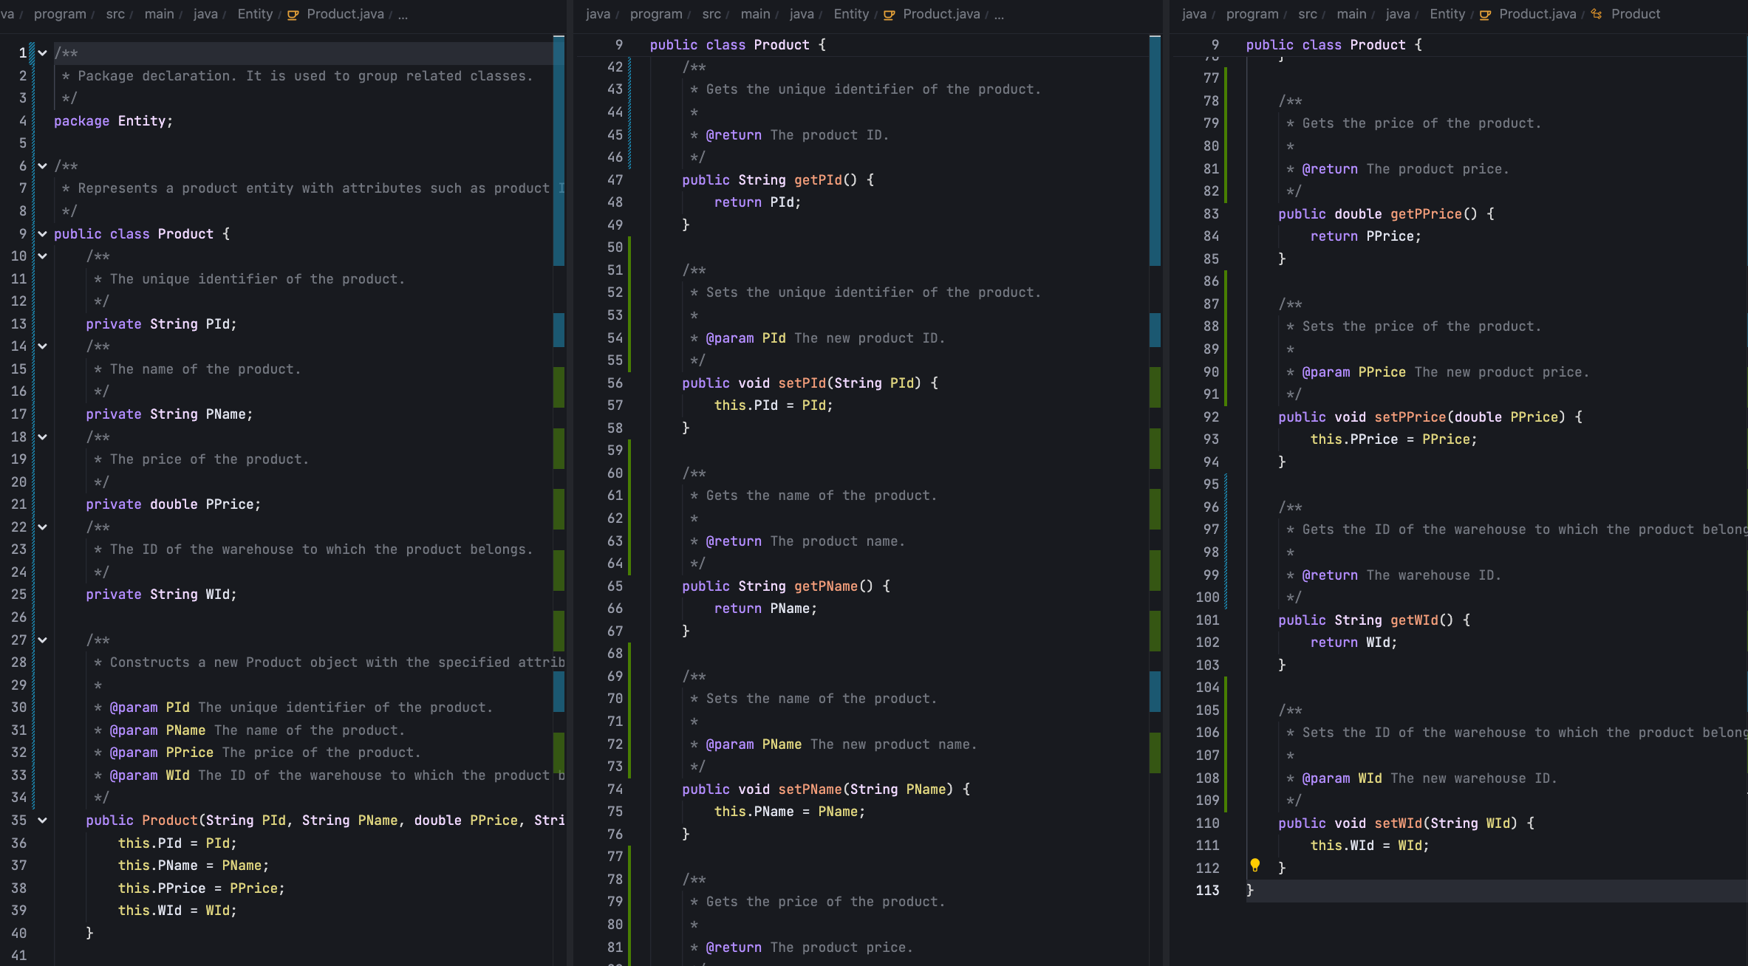

## 3.2 Record of SoftDev

### 3.2.1 Branch Records

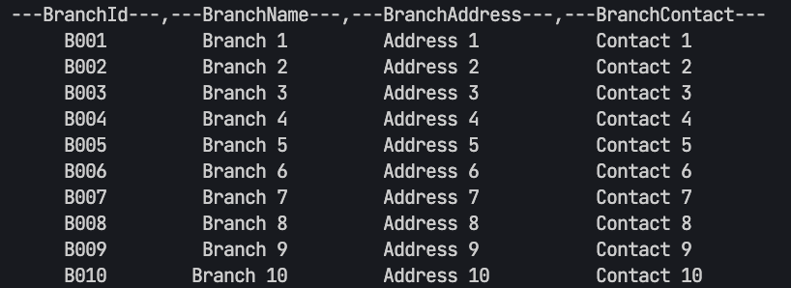

### 3.2.2 Employee Records

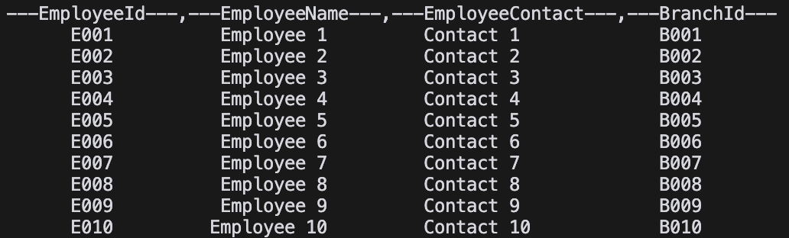

### 3.2.3 Warehouse Records

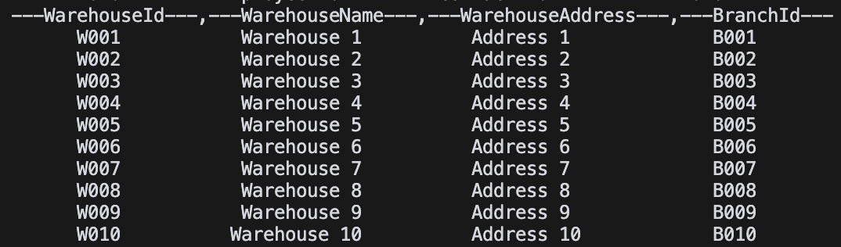

### 3.2.4 Supplier Records

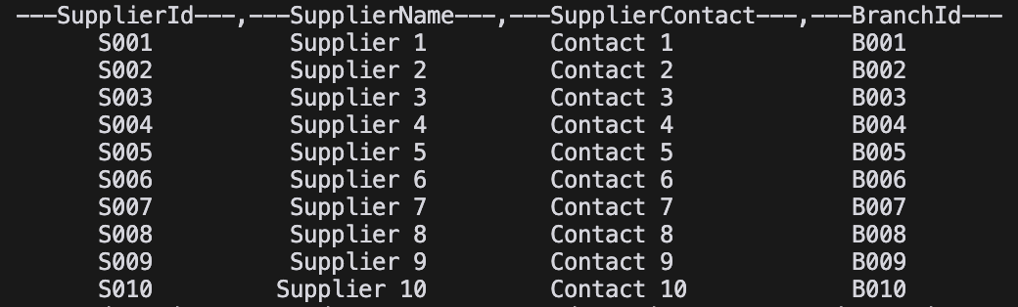

### Product Records

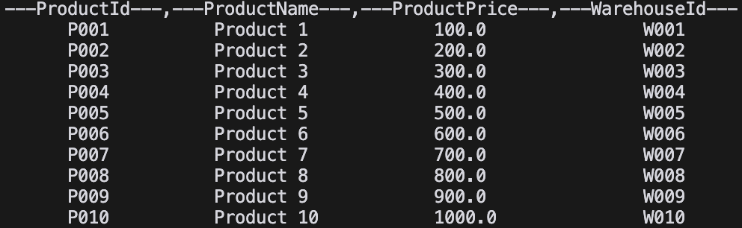

# Test Case

## 4.1 Branch test case

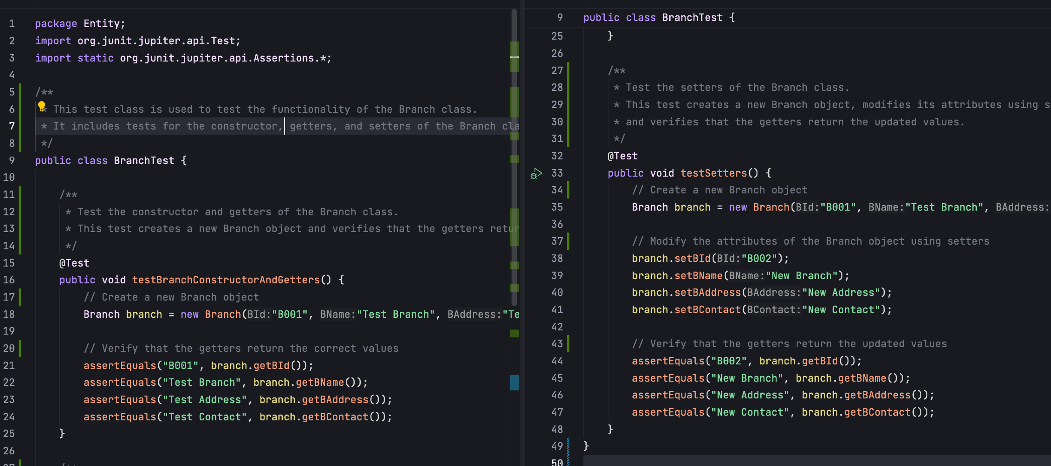

Ouput:

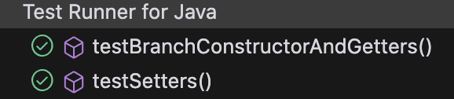

## 4.2 Employee test case

Output:

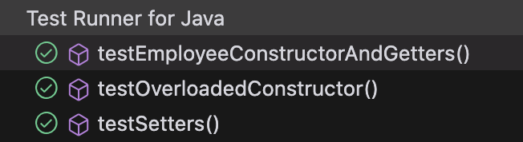

## 4.3 Warehouse test case

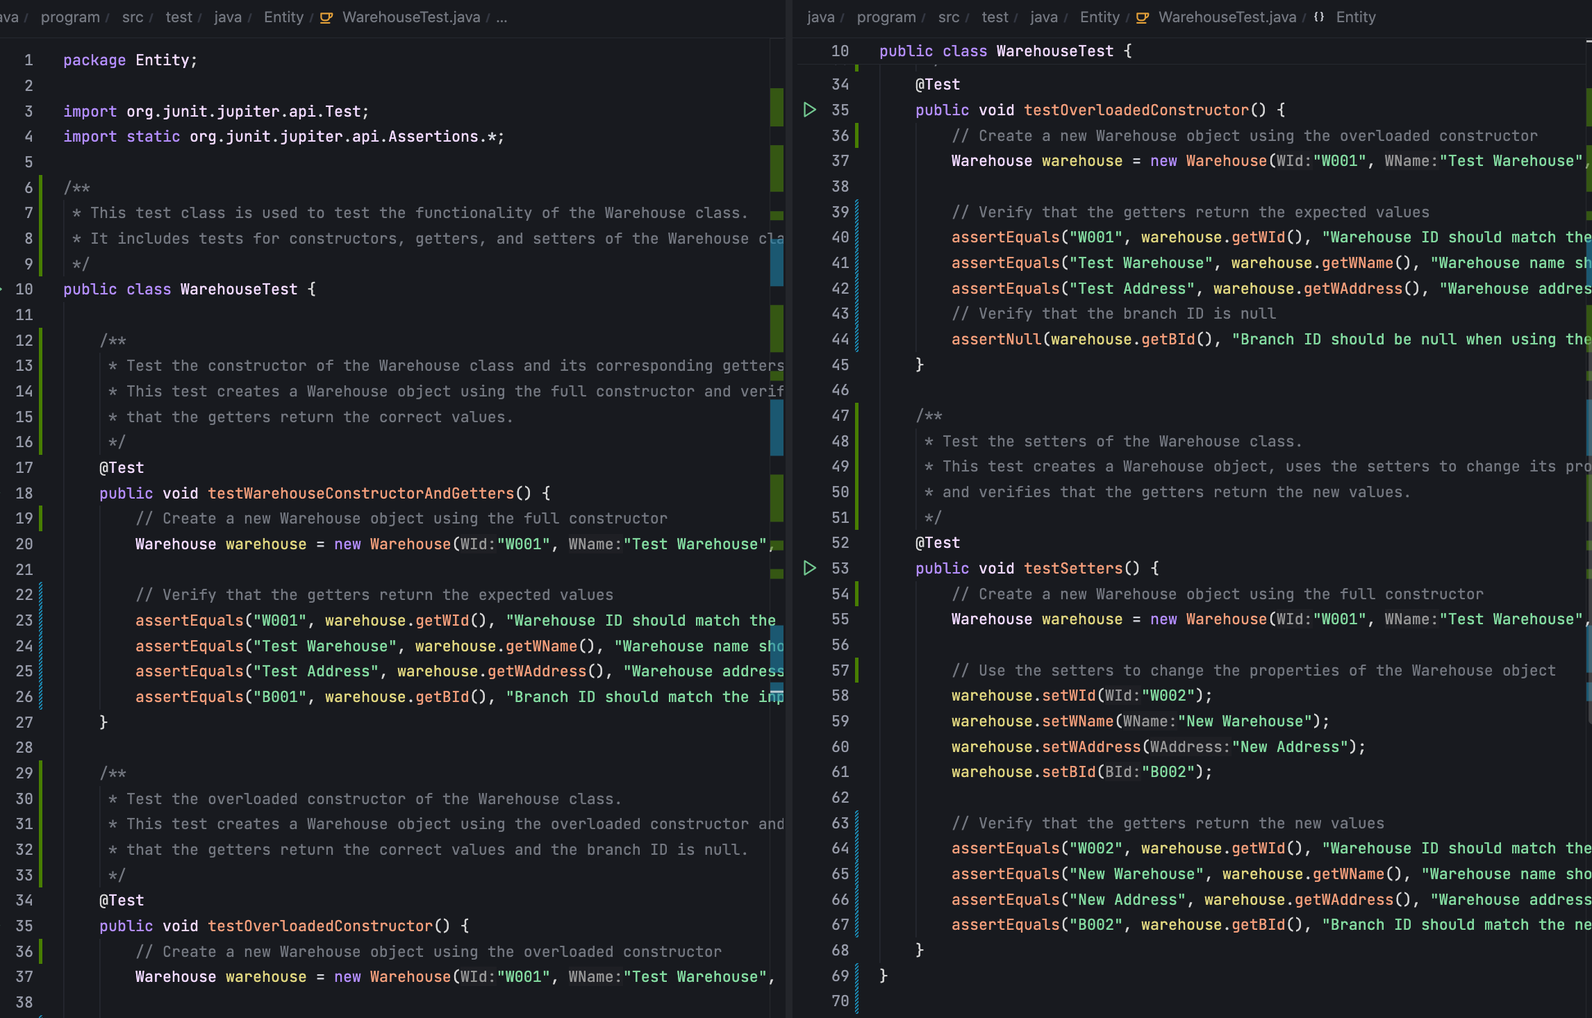

Output:

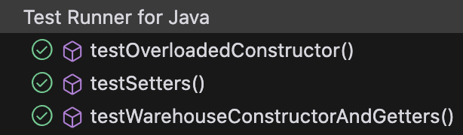

## 4.4 Supplier test case

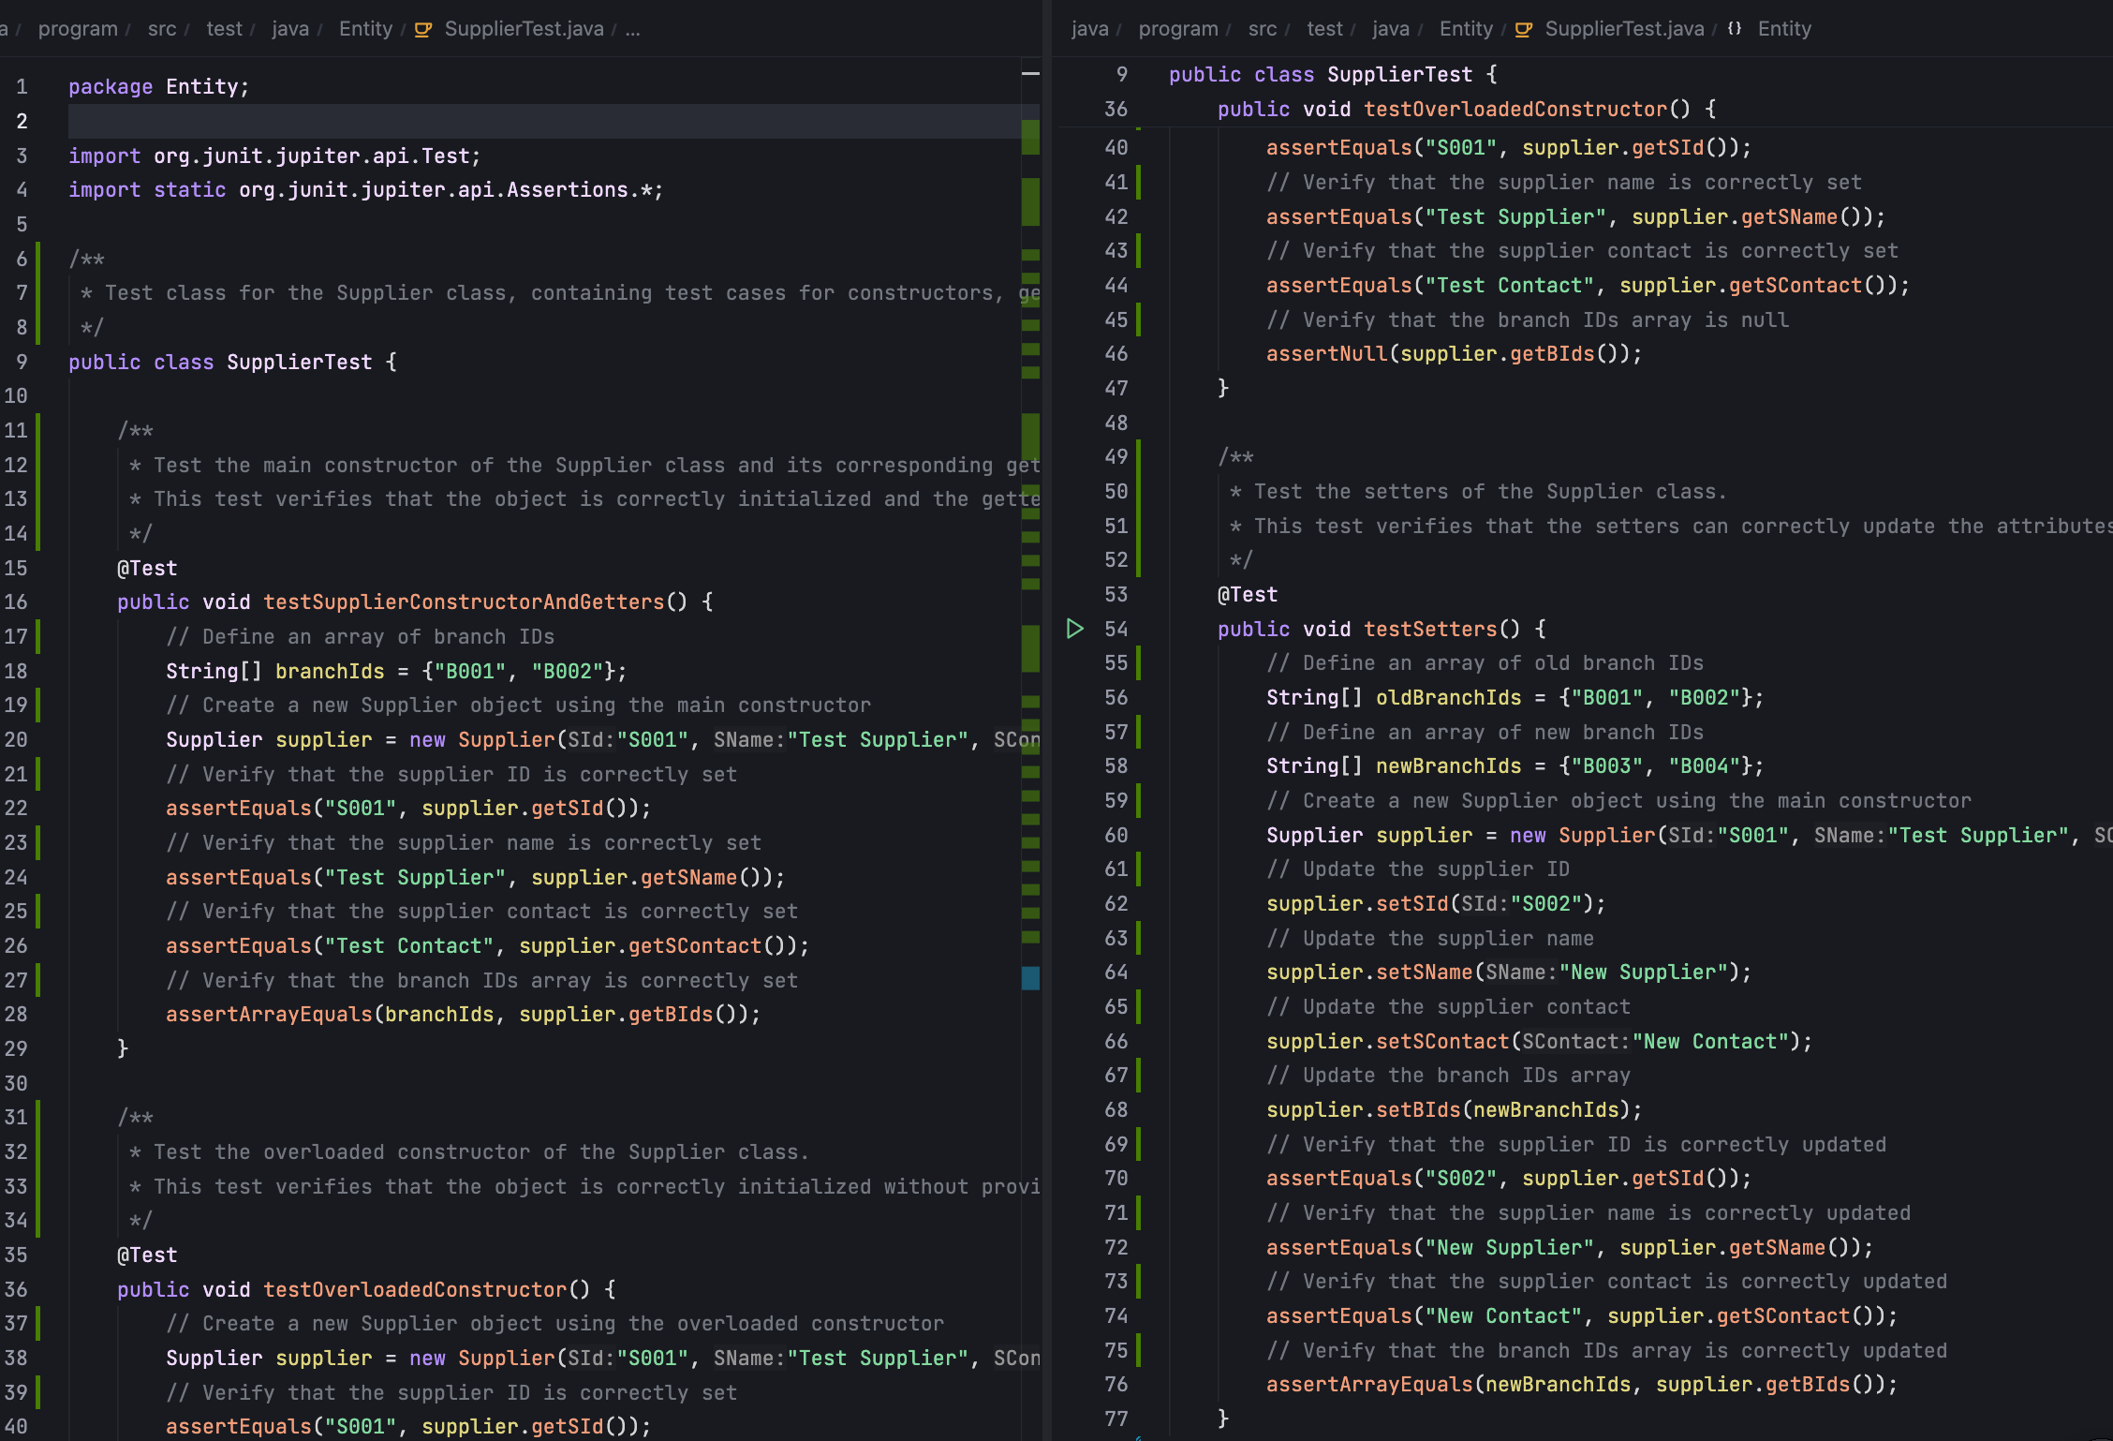

Output

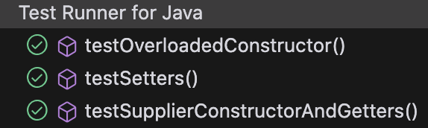

## 4.5 Product test case

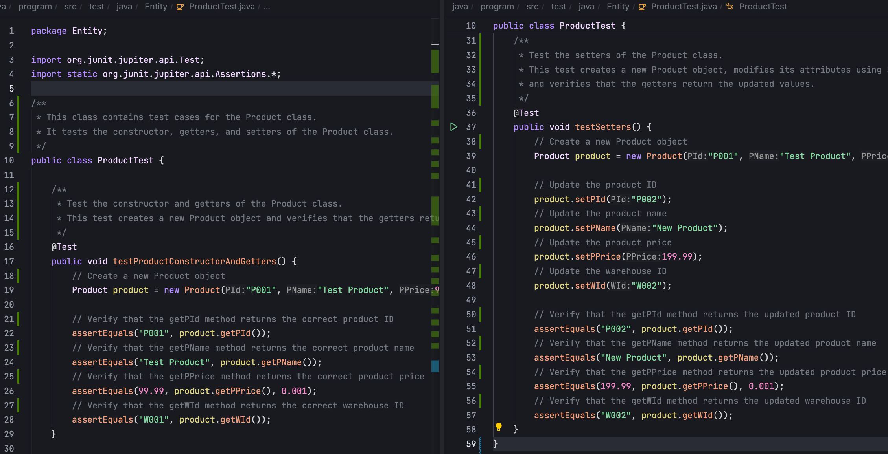

Output:

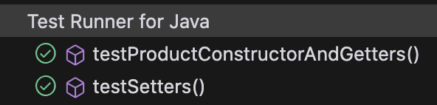

# Program Listings(with coments and explanations)

Now that all individual classes have been explained, I will proceed to elaborate on the main program.

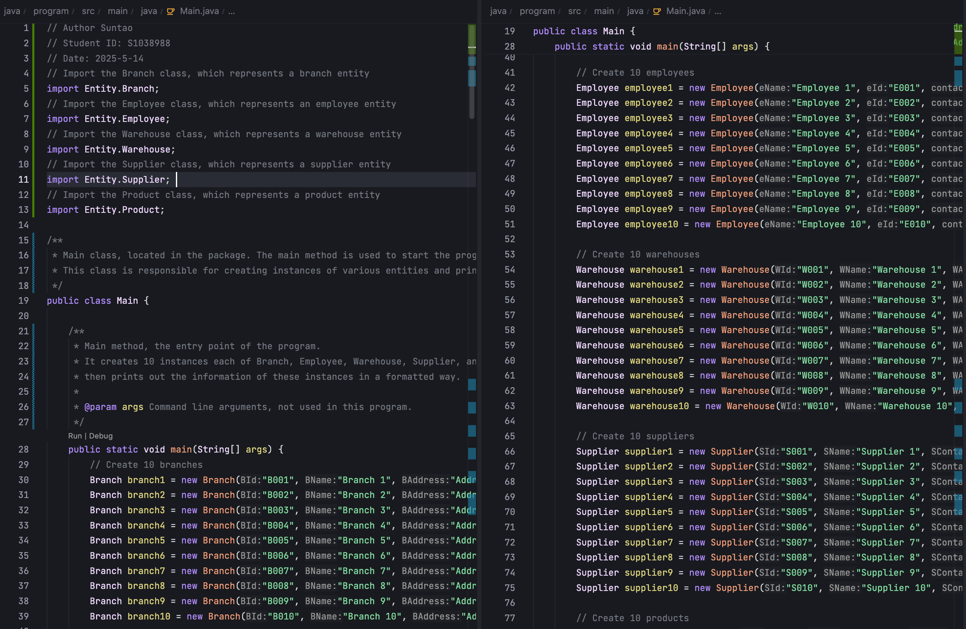

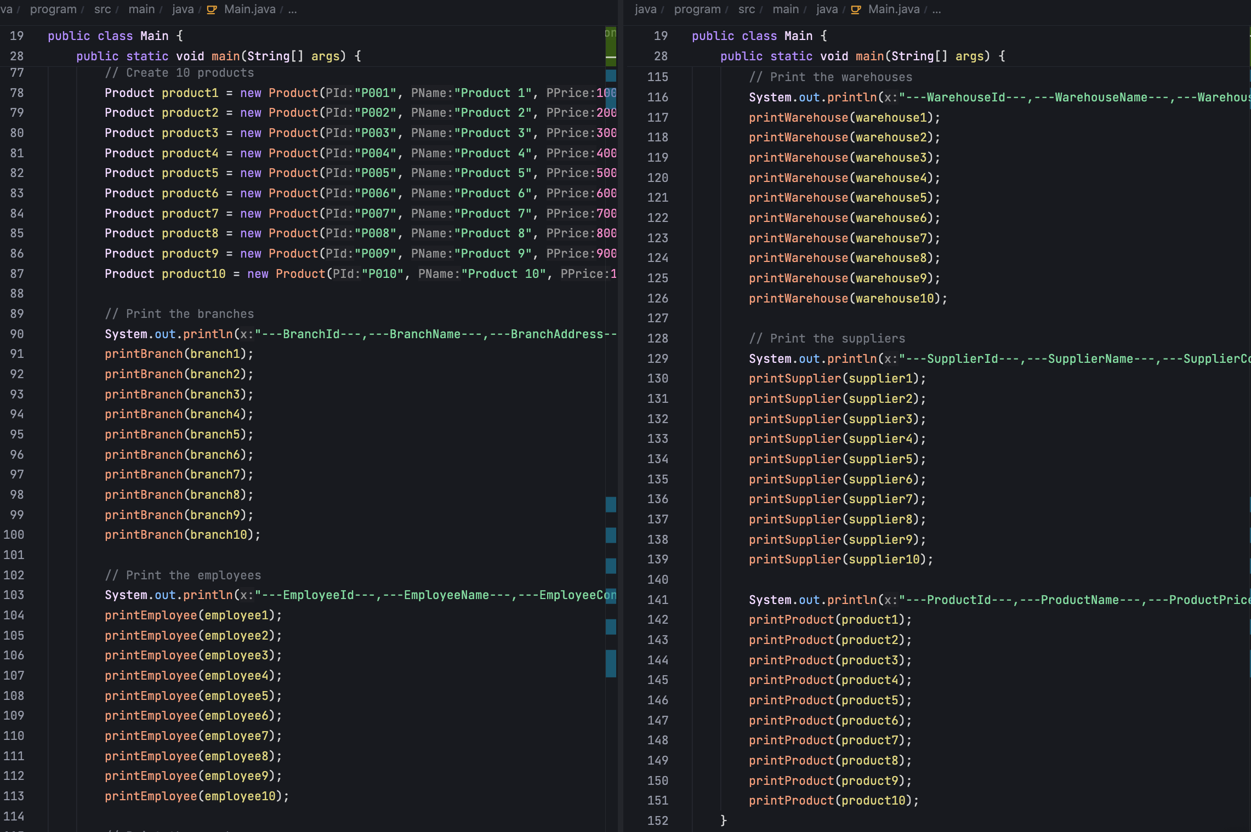

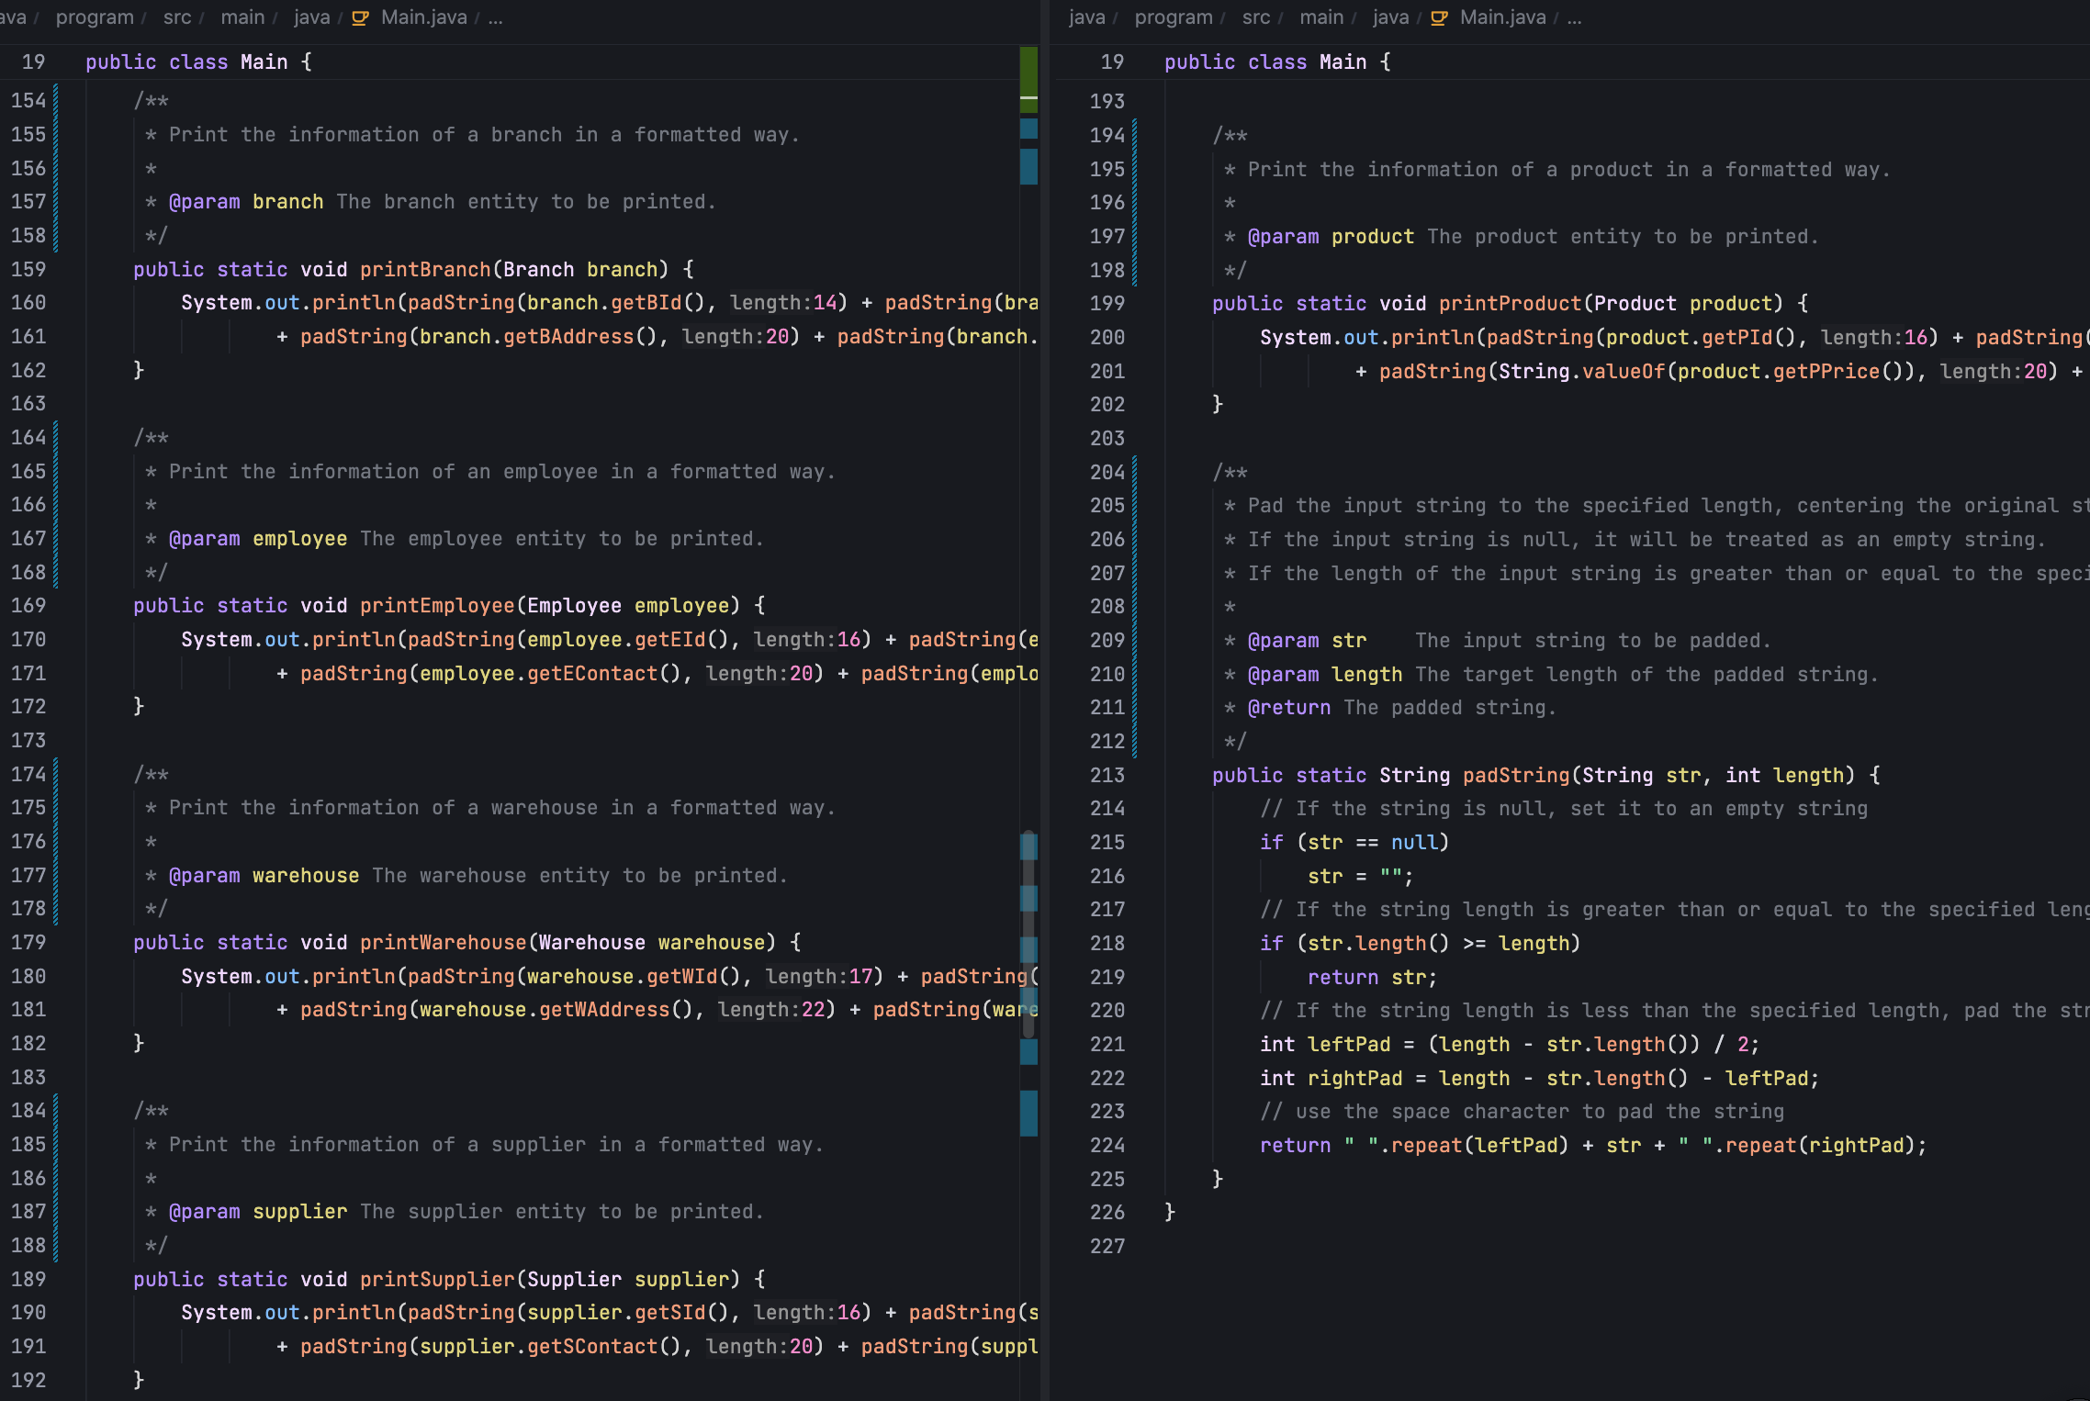

# Critical Evaluation

## 6.1 Strengths

* Clear object - oriented code structure. Each entity class has a single responsibility and well - defined properties and methods.
* High test coverage: Comprehensive unit tests have been written for each entity class, covering constructors, getters/setters, and other basic functions.
* Consistent naming conventions and thorough code comments can improve code readability and maintainability.

## 6.2 Weaknesses

* Lack of data validation –

The system currently lacks data validation. Input parameters like ID format, price range, and contact format aren't effectively verified. This can cause data integrity issues, letting in non - compliant data, disrupting business processes, affecting data analysis accuracy, and burdening data quality maintenance.

* Weakness in Entity Class Relationships

The relationship architecture among entity classes is too simplistic. It's merely maintained via ID strings without strong type constraints. This flaw endangers data consistency. During complex operations like data updates and associated queries, it easily causes data association chaos and frequent inconsistency errors. This significantly undermines data reliability and stability in the system, and raises the complexity and error rate of data management.

* Absence of Serializable Interface

The system lacks the `Serializable` interface implementation, posing potential hurdles in data persistence. During data storage, transmission, and recovery, it may trigger compatibility issues and errors, like inaccurate object restoration, data loss or corruption, severely jeopardizing data persistence.

## 6.3 Future Enhancement

1. Suggest adding data validation layer:

/**

* Sets the branch ID.

* Validates that the provided branch ID is not null and matches the format of 'B' followed by three digits.

*

* @param branchId The branch ID to be set.

* @throws IllegalArgumentException if the branch ID is null or does not match the required format.

*/

public void setBId(String branchId) {

// Validate if the branch ID is null or does not match the format of 'B' followed by three digits

if (branchId == null || !branchId.matches("B\\d{3}")) {

throw new IllegalArgumentException("Invalid branch ID format. It should match 'B' followed by three digits.");

}

this.BId = branchId;

}

2.Consider adding business logic layer:

/**

* This class provides services related to the Branch entity.

* It manages a list of branches and offers methods to add new branches.

*/

public class BranchService { // List to store all branches

private List<Branch> branches;

/**

* Adds a new branch to the list.

* Performs business logic validation to ensure that the branch does not already exist.

*

* @param branch The branch to be added.

* @throws BusinessException if the branch with the same ID already exists.

*/

public void addBranch(Branch branch) {

// Validate business logic: check if the branch already exists

if (isBranchExists(branch.getBId())) {

throw new BusinessException("Branch already exists");

} // Add the branch to the list

branches.add(branch);

}

// You may need to initialize the 'branches' list in the constructor

public BranchService() {

this.branches = new ArrayList<>();

}

/**

* Checks if a branch with the given ID already exists in the list.

*

* @param branchId The ID of the branch to check.

* @return true if the branch exists, false otherwise.

*/

private boolean isBranchExists(String branchId) {

for (Branch b : branches) {

if (b.getBId().equals(branchId)) {

return true;

}

}

return false;

}

}

3. Suggest implementing domain model relationships:

/**

* Represents a branch in a company, containing a list of employees and warehouses.

*/

public class Branch {

// List of employees belonging to this branch

private List<Employee> employees;

// List of warehouses belonging to this branch

private List<Warehouse> warehouses;

/**

* Adds an employee to the branch if the employee's branch ID matches the branch's ID.

*

* @param employee The employee to be added.

*/

public void addEmployee(Employee employee) {

// Check if the employee's branch ID matches the branch's ID

if (employee.getBId().equals(this.getBId())) {

// Add the employee to the list if the IDs match

employees.add(employee);

}

}

}

These improvements would make the project more robust and complete. Additionally, consider adding:

• Exception handling mechanism

• Logging functionality

• Data persistence layer

• Transaction management

• Access control system

These additions would make the project more suitable for enterprise-level applications.

# References

Horstmann, C.S. (2019) *Big Java: Early Objects, 7e Abridged Bound Print Companion with Wiley E-Text Reg Card Set*.

Horstmann, C. (2021) *Core Java, Volume I: Fundamentals, 12e*. Addison-Wesley Professional.

# Plagiarism Checker

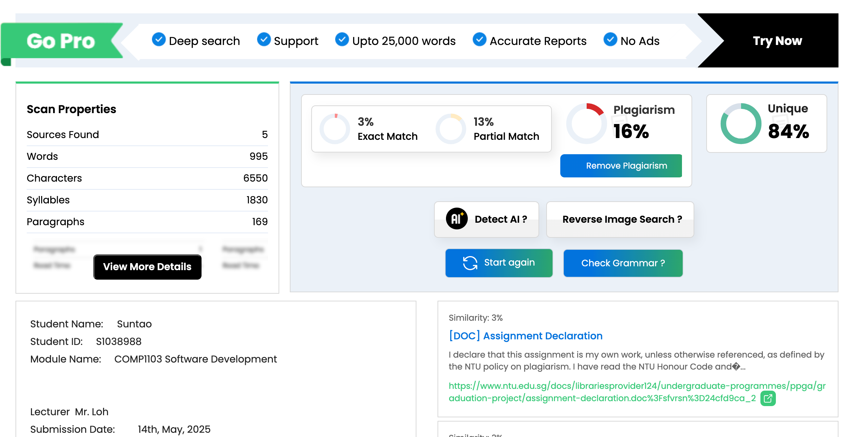

# Presentation

This project offers a short-term fix for the issues Mr. John Doe faces. Its goal is to help the client resolve these problems wholeheartedly. Currently, it's in the design and early development phase. We've applied object-oriented programming, using classes to model business relationships. Based on the client's branches, we created the "Branch" class as a central entity. To manage branch employees, we set up the "Employee" class, which holds all employee info and operations. For branch storage and inventory, the "Warehouse" class manages warehouse details and operations. The "Supplier" class manages external partners, and the "Product" class handles the business's sold products. Many of these classes relate to the "Branch" class. Employees belong to branches, warehouses are associated with them, and suppliers interact with branches. Products connect to the "Warehouse" class as they're stored there. Once class relationships are established and verified, we'll develop the next-stage business logic, implementing core system functions. Finally, we'll work on developing, testing, and launching the Graphical User Interface (GUI) to offer the client an intuitive platform.